Experiment 14(b): Compare Different K Values

Aim
To compare the performance of the K-Means clustering algorithm for different values of K and identify the most suitable number of clusters.

Algorithm
- Start the R program.
- Load the required dataset.
- Select the numerical attributes to be used for clustering.
- Standardize the selected attributes using scale().
- Apply the K-Means clustering algorithm for different values of K, such as 2, 3, 4, and 5.
- Calculate the Within-Cluster Sum of Squares (WCSS) for each K.
- Store the WCSS values.
- Display the WCSS values for comparison.
- Plot K against WCSS using the Elbow Method.
- Identify the appropriate K value from the point where the decrease in WCSS starts becoming smaller.
- Display the clustering result for the selected K.
- Stop.

R Programming Code
# Experiment 14(b): Compare Different K Values

# Sample dataset
data <- data.frame(
Age = c(22, 25, 27, 30, 35, 40, 42, 45, 50, 52),
Income = c(20, 25, 28, 32, 40, 55, 60, 65, 75, 80)
)

# Display the dataset
print(data)

# Standardize the data
data_scaled <- scale(data)

# Set seed for reproducibility
set.seed(123)

# Different K values
k_values <- 2:5

# Store WCSS values
wcss <- numeric(length(k_values))

# Apply K-Means for different K values
for (i in seq_along(k_values)) {

k <- k_values[i]

km <- kmeans(data_scaled, centers = k, nstart = 25)

wcss[i] <- km$tot.withinss
}

# Display WCSS values
result <- data.frame(
K = k_values,
WCSS = round(wcss, 3)
)

print(result)

# Plot Elbow Curve
plot(k_values, wcss,
type = "b",
pch = 19,
xlab = "Number of Clusters (K)",
ylab = "Within-Cluster Sum of Squares",
main = "Elbow Method for Selecting K")

# Select K = 3 based on the elbow
set.seed(123)

final_kmeans <- kmeans(data_scaled,
centers = 3,
nstart = 25)

# Display cluster assignments
data$Cluster <- final_kmeans$cluster

print(data)

# Display cluster centers
print(final_kmeans$centers)

Output
Model formula:
Result ~ Hours + Attendance

Fitted party:
[1] root: Pass (n = 10, err = 40.0%)

Number of inner nodes: 0
Number of terminal nodes: 1
Predicted Classes:
1 1 1 1 1 1 1 1 1 1
Pass Pass Pass Pass Pass Pass Pass Pass Pass Pass
Levels: Fail Pass

Confusion Matrix:
Predicted
Actual Fail Pass
Fail 0 4
Pass 0 6

Accuracy = 60 %

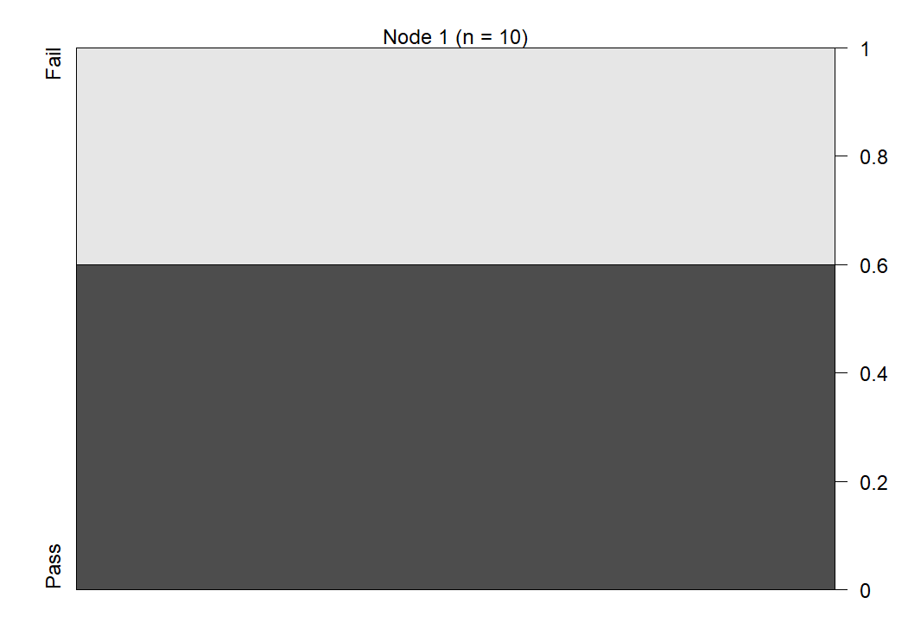

Result:
Thus, the K-Means algorithm was successfully applied for different K values (2, 3, 4, and 5). The WCSS values were compared using the Elbow Method, and K = 3 was selected as the suitable number of clusters for the given dataset.

